Purpose

Build a cloud that can host BitBeat's public website. To do this, we will build an Amazon VPC with subnets and an internet gateway.

Troubleshoot

The lab was completed without any problems. VPC, subnet, and internet gateway successfully created.

Screenshots

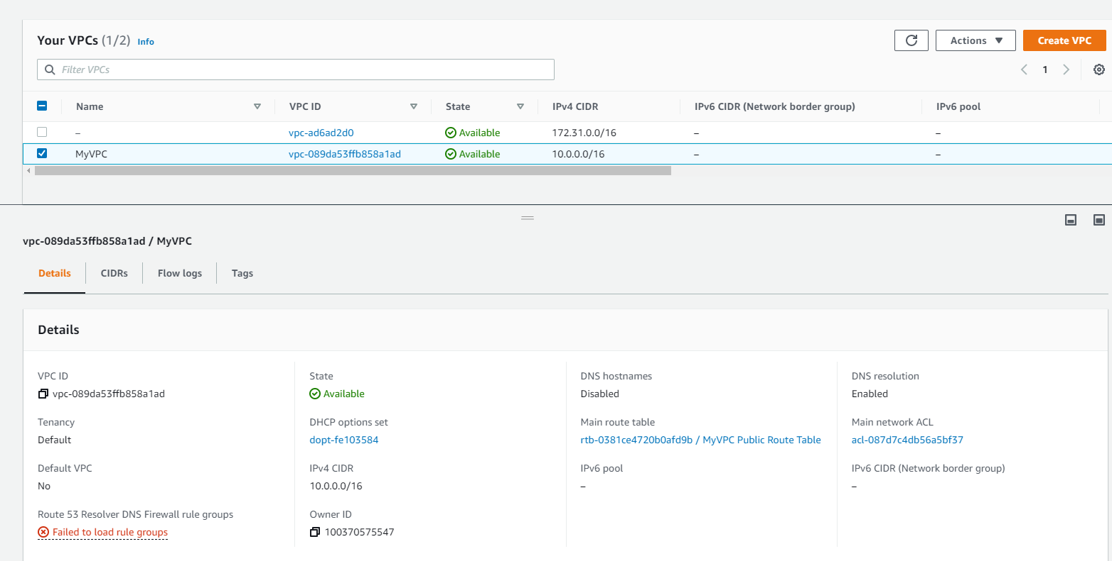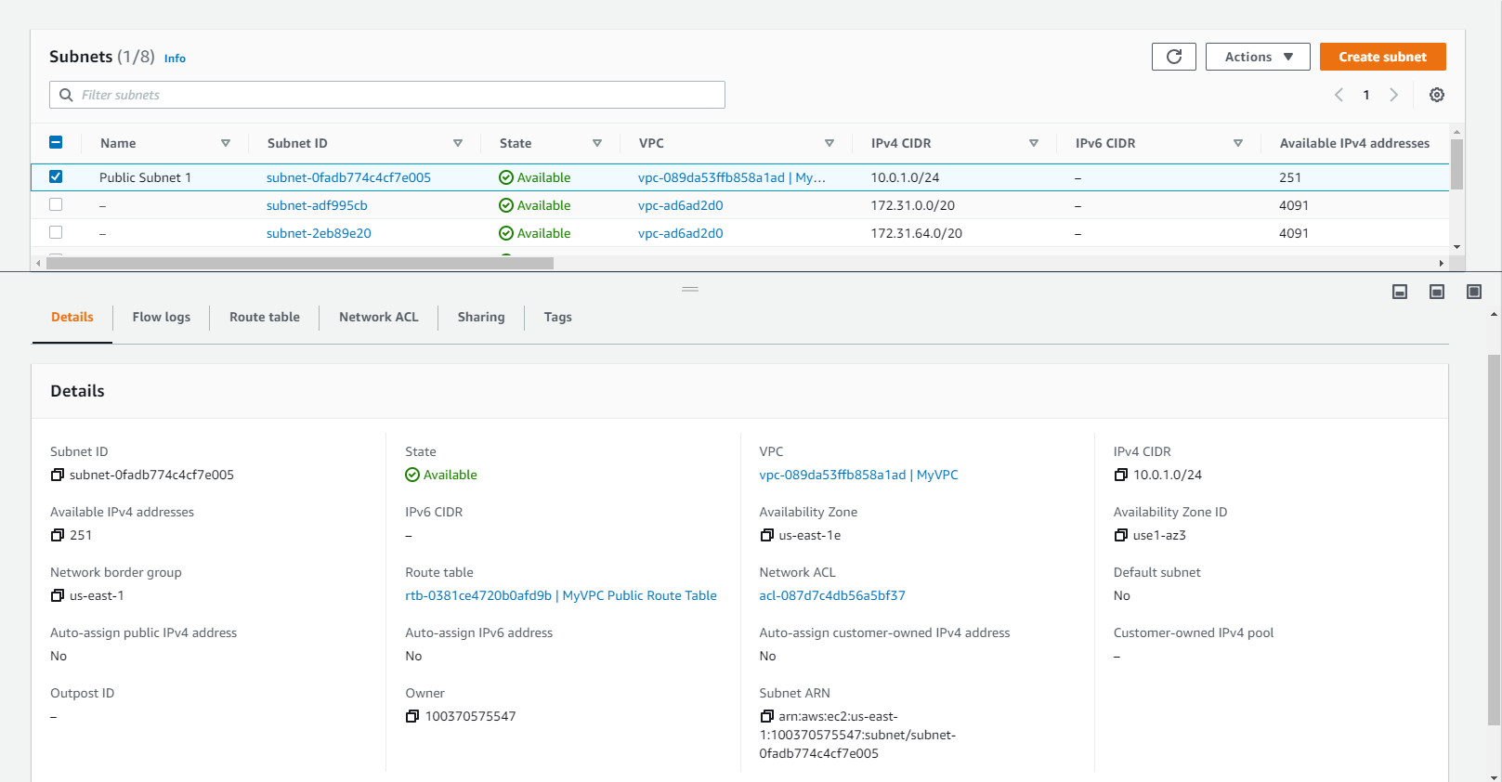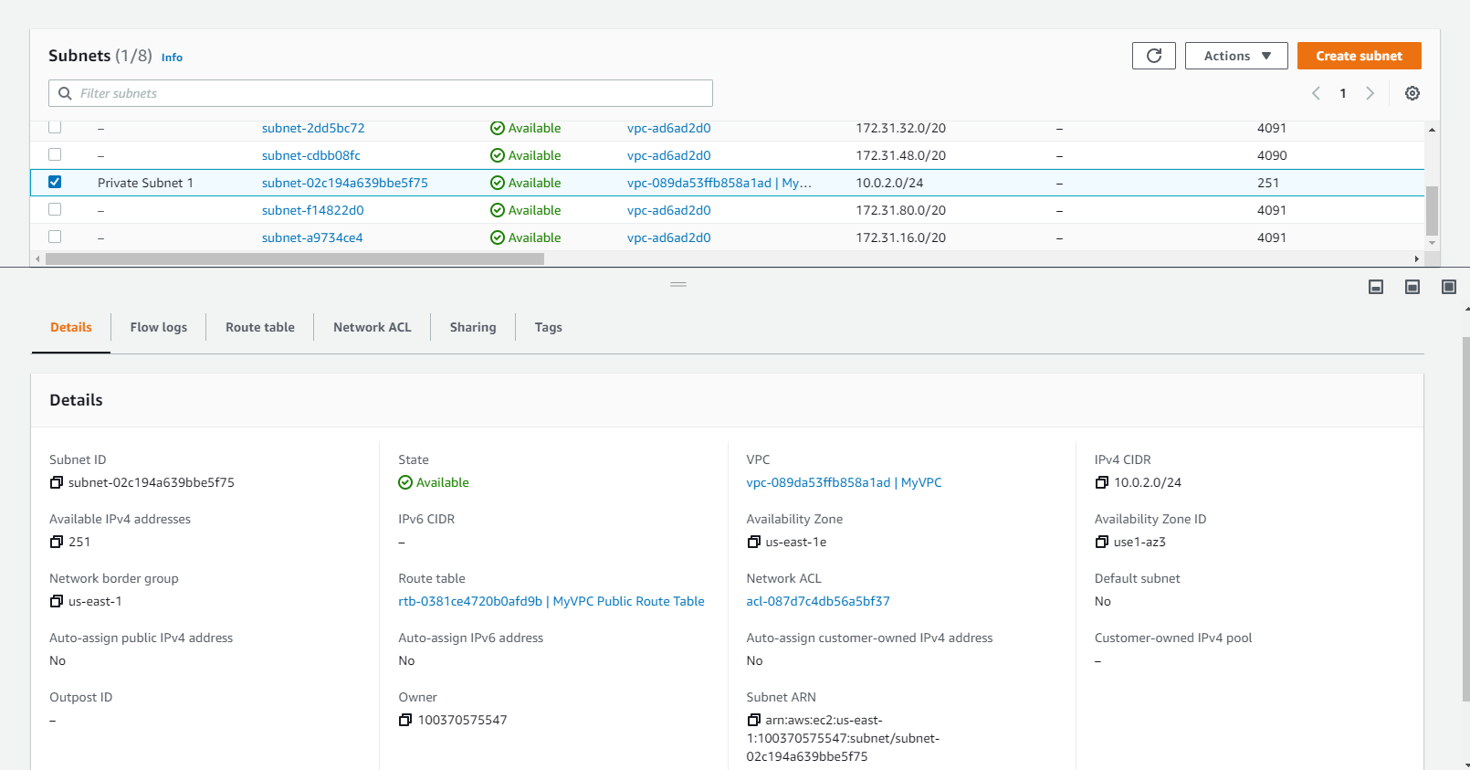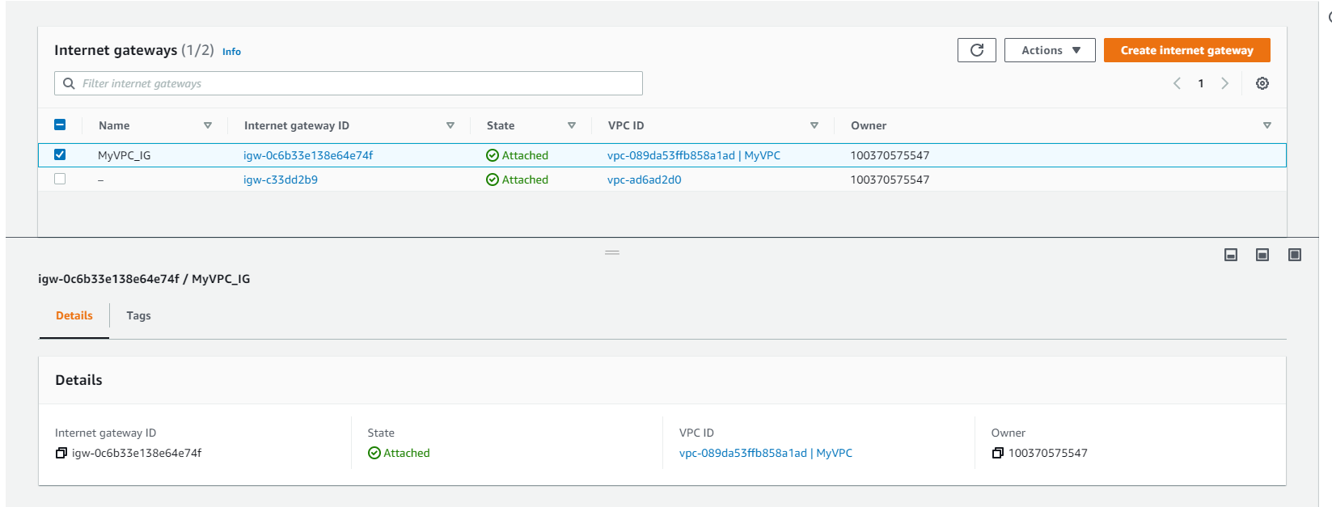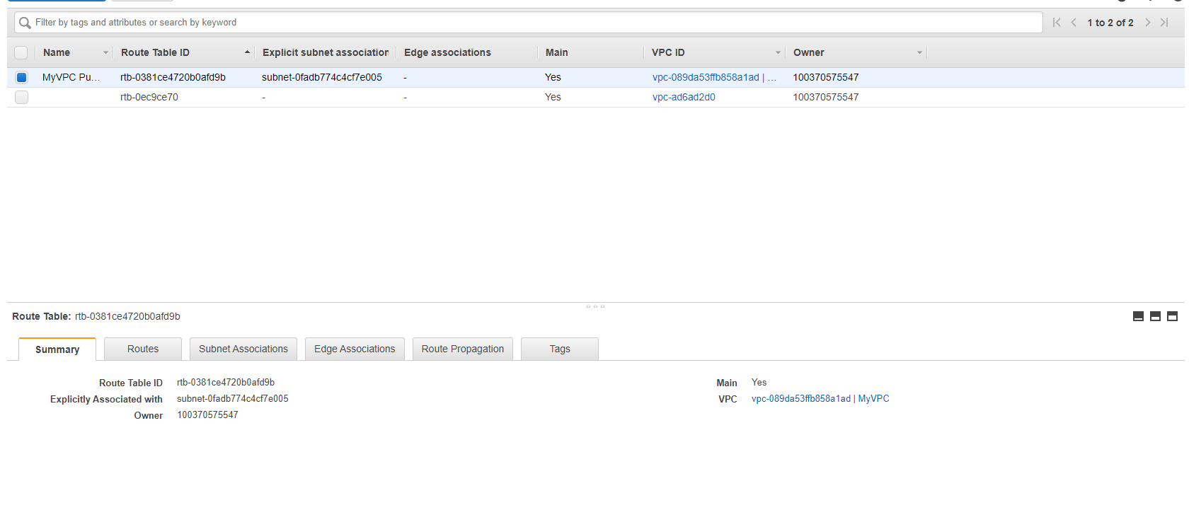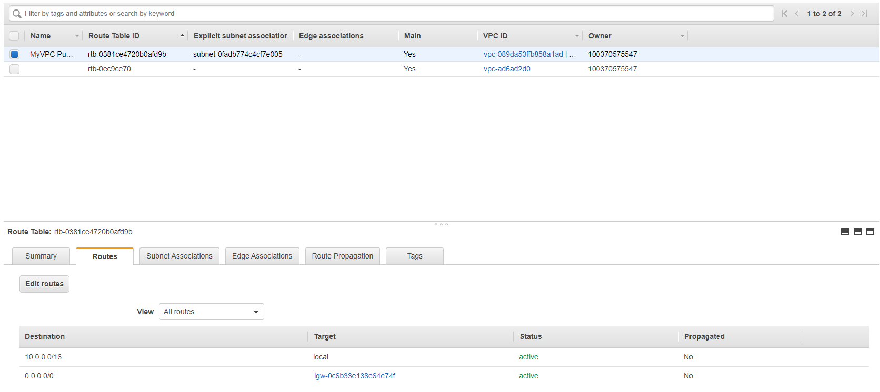

Answers

* Virtual private cloud
* An on demand configurable pool of shared resources allocated within a public cloud environment
* 10.0.1.0/24; 10.0.2.0/24
* Provide a target for VPC route tables and perform NAT assigned to public IPv4 addresses
* No, it can’t, only the public subnet can
* NAT is a method of mapping IP address space into another by modifying network address information in the IP header of packets while they are in transit across a traffic routing table
* /16
* /28

1. True, every account has its own separated virtual network.
2. True, subnets include a range of IP address in VPC
3. False, it does not have any rules
4. True, internet gateway is a managed Amazon VPC component that allows communication between internet and VPC
5. True
6. Web servers are in public subnets, and applications and databases are in private subnets
7. To make the VPC able to connect to the internet
8. Point traffics destined for the public internet to the internet gateway.